Supplementary Data 1
Table S1. List of the samples used for transcriptomic studies
Body region  Specimen | Oscular rim | Cormus tubes | Diverticula
Specimen 1 | Low RNA concentration | C1 | Low RNA concentration
Specimen 2 | O2 | C2 | D2
Specimen 3 | O3 | Low RNA concentration | D3
Specimen 4 | O4 | C4 | D4
Specimen 5 | Whole specimen library for de novo transcriptome assemblage

Table S2. Total number of read pairs in each library used in the de novo assembly
 | Raw reads | Clean reads
C1 | 45133429 | 28300326
C2 | 40900718 | 25145594
C4 | 47250388 | 29635206
D2 | 56828555 | 36695888
D3 | 53469336 | 29490522
D4 | 43290687 | 23720747
O2 | 41079035 | 23860834
O3 | 44375353 | 20121902
O4 | 44149314 | 25562135
Ref | 132258912 | 86276001

Table S3. Summary statistics of the Leucosolenia corallorrhiza transcriptome de novo assembly
Transcripts number |  | 322094
'Genes’ number |  | 247335
Transcripts mean length |  | 635,84
Transcripts median length |  | 347
Transcripts N50 |  | 902
Percent GC |  | 49,84%
Ex90N50 |  | 2660
“isoform” level | Total complete BUSCO | 91,6%
“isoform” level | Complete single-copy BUSCO | 47,1%
“isoform” level | Complete duplicated BUSCO | 44,5%
“isoform” level | Partial BUSCO | 3,1%
“gene” level | Total complete BUSCO | 86,6%
“gene” level | Complete single-copy BUSCO | 79,0%
“gene” level | Complete duplicated BUSCO | 9,5%
“gene” level | Partial BUSCO | 4,1%

Table S4. List of the components of Wnt and Tgfβ signaling pathways recovered from Leucosolenia corallorrhiza transcriptome and log-fold changes in their expression across different regions of the sponge body
gene | gene_name | pathway | Full name | DE status | LFC osculum vs (cormus+divert) | LFC osculum vs cormus | LFC osculum vs divert
TRINITY_DN126_c2_g1 | LcoCtnnbA | Wnt | Beta-catenin A | not_DET | . | . | .
TRINITY_DN2683_c0_g1 | LcoCtnnbB | Wnt | Beta-catenin B | not_DET | . | . | .
TRINITY_DN3083_c0_g1 | LcoDvlA | Wnt | Dishevelled-related A | not_DET | . | . | .
TRINITY_DN1052_c0_g1 | LcoDvlB | Wnt | Dishevelled-related B | not_DET | . | . | .
TRINITY_DN13256_c0_g5 | LcoFzdA | Wnt | Frizzled-related protein A | not_DET | . | . | .
TRINITY_DN27046_c0_g1 | LcoFzdB | Wnt | Frizzled-related protein B | not_DET | . | . | .
TRINITY_DN3268_c0_g1 | LcoFzdC | Wnt | Frizzled-related protein C | not_DET | . | . | .
TRINITY_DN16003_c0_g7 | LcoFzdD | Wnt | Frizzled-related protein D | not_DET | . | . | .
TRINITY_DN13802_c0_g1 | LcoGro | Wnt | Groucho | not_DET | . | . | .
TRINITY_DN1473_c1_g1 | LcosFRPA | Wnt | Secreted frizzled-related protein A | DET | 5,51 | 4,27 | 6,69
TRINITY_DN6040_c0_g1 | LcosFRPB | Wnt | Secreted frizzled-related protein B | DET | 2,51 | 2,51 | 2,36
TRINITY_DN6708_c0_g1 | LcosFRPC | Wnt | Secreted frizzled-related protein C | DET | 2,08 | 1,99 | 2,14
TRINITY_DN8586_c0_g1 | LcosFRPD | Wnt | Secreted frizzled-related protein D | DET | 4,26 | 3,89 | 4,38
TRINITY_DN8881_c0_g1 | LcosFRPE | Wnt | Secreted frizzled-related protein E | DET | 0,55 | . | 0,97
TRINITY_DN1412_c0_g1 | LcoTcfA | Wnt | Transcription factor TCF/LEF A | not_DET | . | . | .
TRINITY_DN1928_c0_g2 | LcoTcfB | Wnt | Transcription factor TCF/LEF B | not_DET | . | . | .
TRINITY_DN6997_c0_g1 | LcoWntA | Wnt | Wnt-related A | not_DET | . | . | .
TRINITY_DN22066_c0_g1 | LcoWntB | Wnt | Wnt-related B | not_DET | . | . | .
TRINITY_DN6267_c0_g1 | LcoWntC | Wnt | Wnt-related C | DET | -0,85 | -0,99 | .
TRINITY_DN9485_c0_g1 | LcoWntD | Wnt | Wnt-related D | DET | 1,23 | . | 1,73
TRINITY_DN4089_c0_g1 | LcoWntE | Wnt | Wnt-related E | DET | 1,93 | 2,53 | 1,22
TRINITY_DN24978_c0_g1 | LcoWntF | Wnt | Wnt-related F | DET | 0,87 | . | 1,67
TRINITY_DN13923_c0_g1 | LcoWntG | Wnt | Wnt-related G | DET | 3,79 | 4,09 | 3,43
TRINITY_DN24580_c0_g1 | LcoWntH | Wnt | Wnt-related H | DET | 1,2 | . | 1,10
TRINITY_DN22980_c0_g2 | LcoWntI | Wnt | Wnt-related I | DET | 3,64 | 3,7 | 3,55
TRINITY_DN9622_c0_g1 | LcoWntJ | Wnt | Wnt-related J | DET | 2,98 | 3,35 | 2,57
TRINITY_DN5433_c1_g1 | LcoWntK | Wnt | Wnt-related K | not_DET | . | . | .
TRINITY_DN4030_c0_g1 | LcoWntL | Wnt | Wnt-related L | DET | 1,11 | . | 1,9
TRINITY_DN92696_c0_g1 | LcoWntM | Wnt | Wnt-related M | DET | 3,14 | . | 2,43
TRINITY_DN7697_c0_g1 | LcoWntO | Wnt | Wnt-related O | DET | 2,15 | 2,46 | 1,75
TRINITY_DN8131_c0_g1 | LcoWntP | Wnt | Wnt-related P | not_DET | . | . | .
TRINITY_DN14586_c1_g2 | LcoWntQ | Wnt | Wnt-related Q | not_DET | . | . | .
TRINITY_DN7543_c0_g1 | LcoWntR | Wnt | Wnt-related R | DET | 1,23 | 1,4 | 0,99
TRINITY_DN1168_c0_g2 | LcoWntS1 | Wnt | Wnt-related S1 | DET | . | -1,32 | .
TRINITY_DN1168_c0_g1 | LcoWntS2 | Wnt | Wnt-related S2 | not_DET | . | . | .
TRINITY_DN17342_c0_g1 | LcoWntT | Wnt | Wnt-related T | not_DET | . | . | .
TRINITY_DN1310_c0_g1 | LcoBra-likeA | TF | Brachyury-like T-box A | DET | -1,03 | -1,64 | .
TRINITY_DN13186_c0_g1 | LcoBra-likeB | TF | Brachyury-like T-box B | not_DET | . | . | .
TRINITY_DN389_c0_g1 | LcoSmad1/5 | TgfB | Smad1/5 | not_DET | . | . | .
TRINITY_DN11284_c0_g1 | LcoSmad2/3 | TgfB | Smad2/3 | DET | 0,74 | . | 0,75
TRINITY_DN1281_c5_g1 | LcoSmad4 | TgfB | Smad4 | not_DET | . | . | .
TRINITY_DN7434_c1_g1 | LcoSmad4 | TgfB | Smad4 | not_DET | . | . | .
TRINITY_DN26606_c0_g1 | LcoSmad6/7A | TgfB | Smad6/7A | not_DET | . | . | .
TRINITY_DN9491_c0_g1 | LcoSmad6/7B | TgfB | Smad6/7B | not_DET | . | . | .
TRINITY_DN3690_c0_g1 | LcoSmadRb | TgfB | SmadRb | not_DET | . | . | .
TRINITY_DN11883_c0_g1 | LcoTgfbA/C | TgfB | Transforming growth factor-beta-related A/C | DET | . | . | -1,81
TRINITY_DN11773_c0_g1 | LcoTgfbB | TgfB | Transforming growth factor-beta-related B | DET | . | . | 1,26
TRINITY_DN3602_c0_g4 | LcoTgfbD | TgfB | Transforming growth factor-beta-related D | not_DET | . | . | .
TRINITY_DN127029_c0_g1 | LcoTgfbE | TgfB | Transforming growth factor-beta-related E | DET | 1,98 | . | 2,42
TRINITY_DN3326_c0_g1 | LcoTgfbF | TgfB | Transforming growth factor-beta-related F | not_DET | . | . | .
TRINITY_DN5564_c0_g1 | LcoTgfbG1 | TgfB | Transforming growth factor-beta-related G1 | DET | . | . | -1,19
TRINITY_DN5591_c2_g1 | LcoTgfbG2 | TgfB | Transforming growth factor-beta-related G2 | not_DET | . | . | .
TRINITY_DN17370_c0_g1 | LcoTgfbH | TgfB | Transforming growth factor-beta-related H | DET | 2,76 | 2,8 | 2,67
TRINITY_DN5330_c0_g1 | LcoTgfbI | TgfB | Transforming growth factor-beta-related I | not_DET | . | . | .
TRINITY_DN3005_c0_g1 | LcoTgfbJ | TgfB | Transforming growth factor-beta-related J | DET | 4,11 | 4,23 | 3,23
TRINITY_DN48725_c0_g1 | LcoTgfbN1 | TgfB | Transforming growth factor-beta-related N1 | DET | 8,71 | 8,23 | 8,59
TRINITY_DN8889_c0_g1 | LcoTgfbN2 | TgfB | Transforming growth factor-beta-related N2 | not_DET | . | . | .
TRINITY_DN1903_c0_g1 | LcoTgfbP | TgfB | Transforming growth factor-beta-related P | DET | -0,54 | . | .
TRINITY_DN10291_c1_g1 | LcoTgfbU | TgfB | Transforming growth factor-beta-related U | DET | 4,01 | 4,21 | 3,75
TRINITY_DN10522_c0_g1 | LcoTgfbV | TgfB | Transforming growth factor-beta-related V | not_DET | . | . | .
TRINITY_DN15769_c1_g2 | LcoTgfbRIrA | TgfB | TGF-beta receptor type-1 related A | not_DET | . | . | .
TRINITY_DN25172_c0_g1 | LcoTgfbRIrB | TgfB | TGF-beta receptor type-1 related B | not_DET | . | . | .
TRINITY_DN8558_c0_g1 | LcoTgfbRIrC | TgfB | TGF-beta receptor type-1 related C | not_DET | . | . | .
TRINITY_DN5399_c0_g3 | LcoTgfbRIA | TgfB | TGF-beta receptor type-1 A | not_DET | . | . | .
TRINITY_DN163_c0_g1 | LcoTgfbRIB | TgfB | TGF-beta receptor type-1 B | not_DET | . | . | .
TRINITY_DN319_c1_g1 | LcoTgfbRIC | TgfB | TGF-beta receptor type-1 C | not_DET | . | . | .
TRINITY_DN29019_c0_g1 | LcoTgfbRID | TgfB | TGF-beta receptor type-1 D | not_DET | . | . | .
TRINITY_DN3638_c0_g1 | LcoTgfbRIG | TgfB | TGF-beta receptor type-1 G | not_DET | . | . | .
TRINITY_DN8401_c0_g1 | LcoTgfbRIH | TgfB | TGF-beta receptor type-1 H | DET | 1,65 | . | 2,09
TRINITY_DN135_c1_g1 | LcoTgfbRIIr | TgfB | TGF-beta receptor type-2 related | not_DET | . | . | .
TRINITY_DN502_c0_g1 | LcoTgfbRIIA | TgfB | TGF-beta receptor type-2 A | not_DET | . | . | .
TRINITY_DN5593_c0_g1 | LcoTgfbRIIB | TgfB | TGF-beta receptor type-2 B | not_DET | . | . | .
TRINITY_DN3219_c0_g1 | LcoTgfbRIID | TgfB | TGF-beta receptor type-2 D | not_DET | . | . | .
TRINITY_DN15534_c0_g1 | LcoIlborinA | other | Ilborin_like | not_DET | . | . | .
TRINITY_DN841_c0_g1 | LcoIlborinB | other | Ilborin_like_TIM_barrel | DET | -1,07 | -1,7 | .

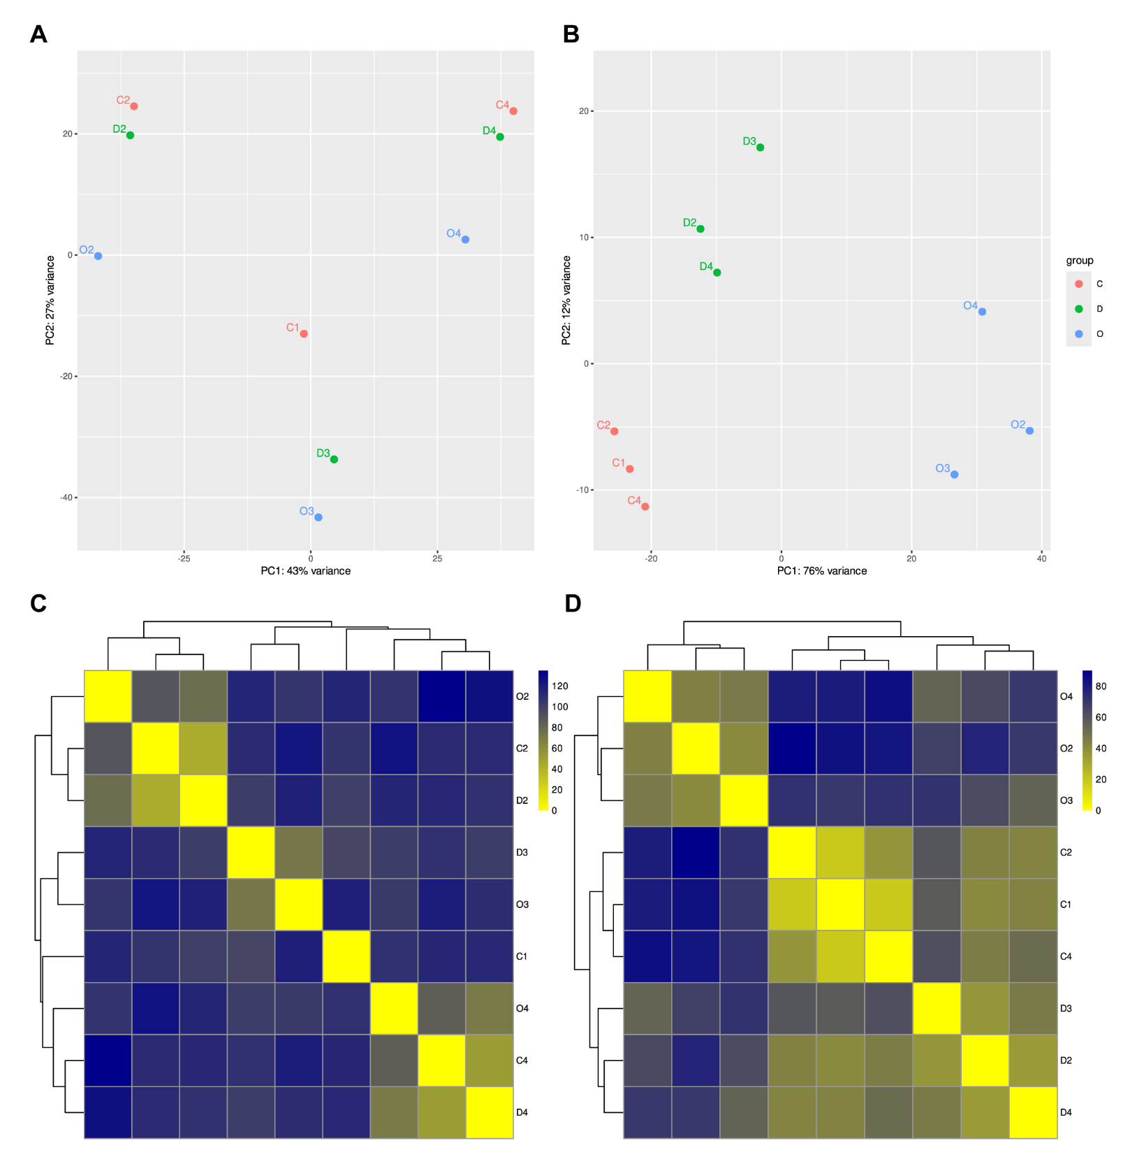
Fig. S1. Sample clustering across different body regions of Leucosolenia corallorrhiza. A, B — principal component analysis (PCA) plots of studied samples. C, D — sample hierarchical clustering; color scale represents Euclidean distance between samples. A, C — without the batch effect correction. B, D — after the batch effect correction. Groups: C — cormus tubes (n = 3), D — diverticula (n = 3), O — oscular rims (n = 3).
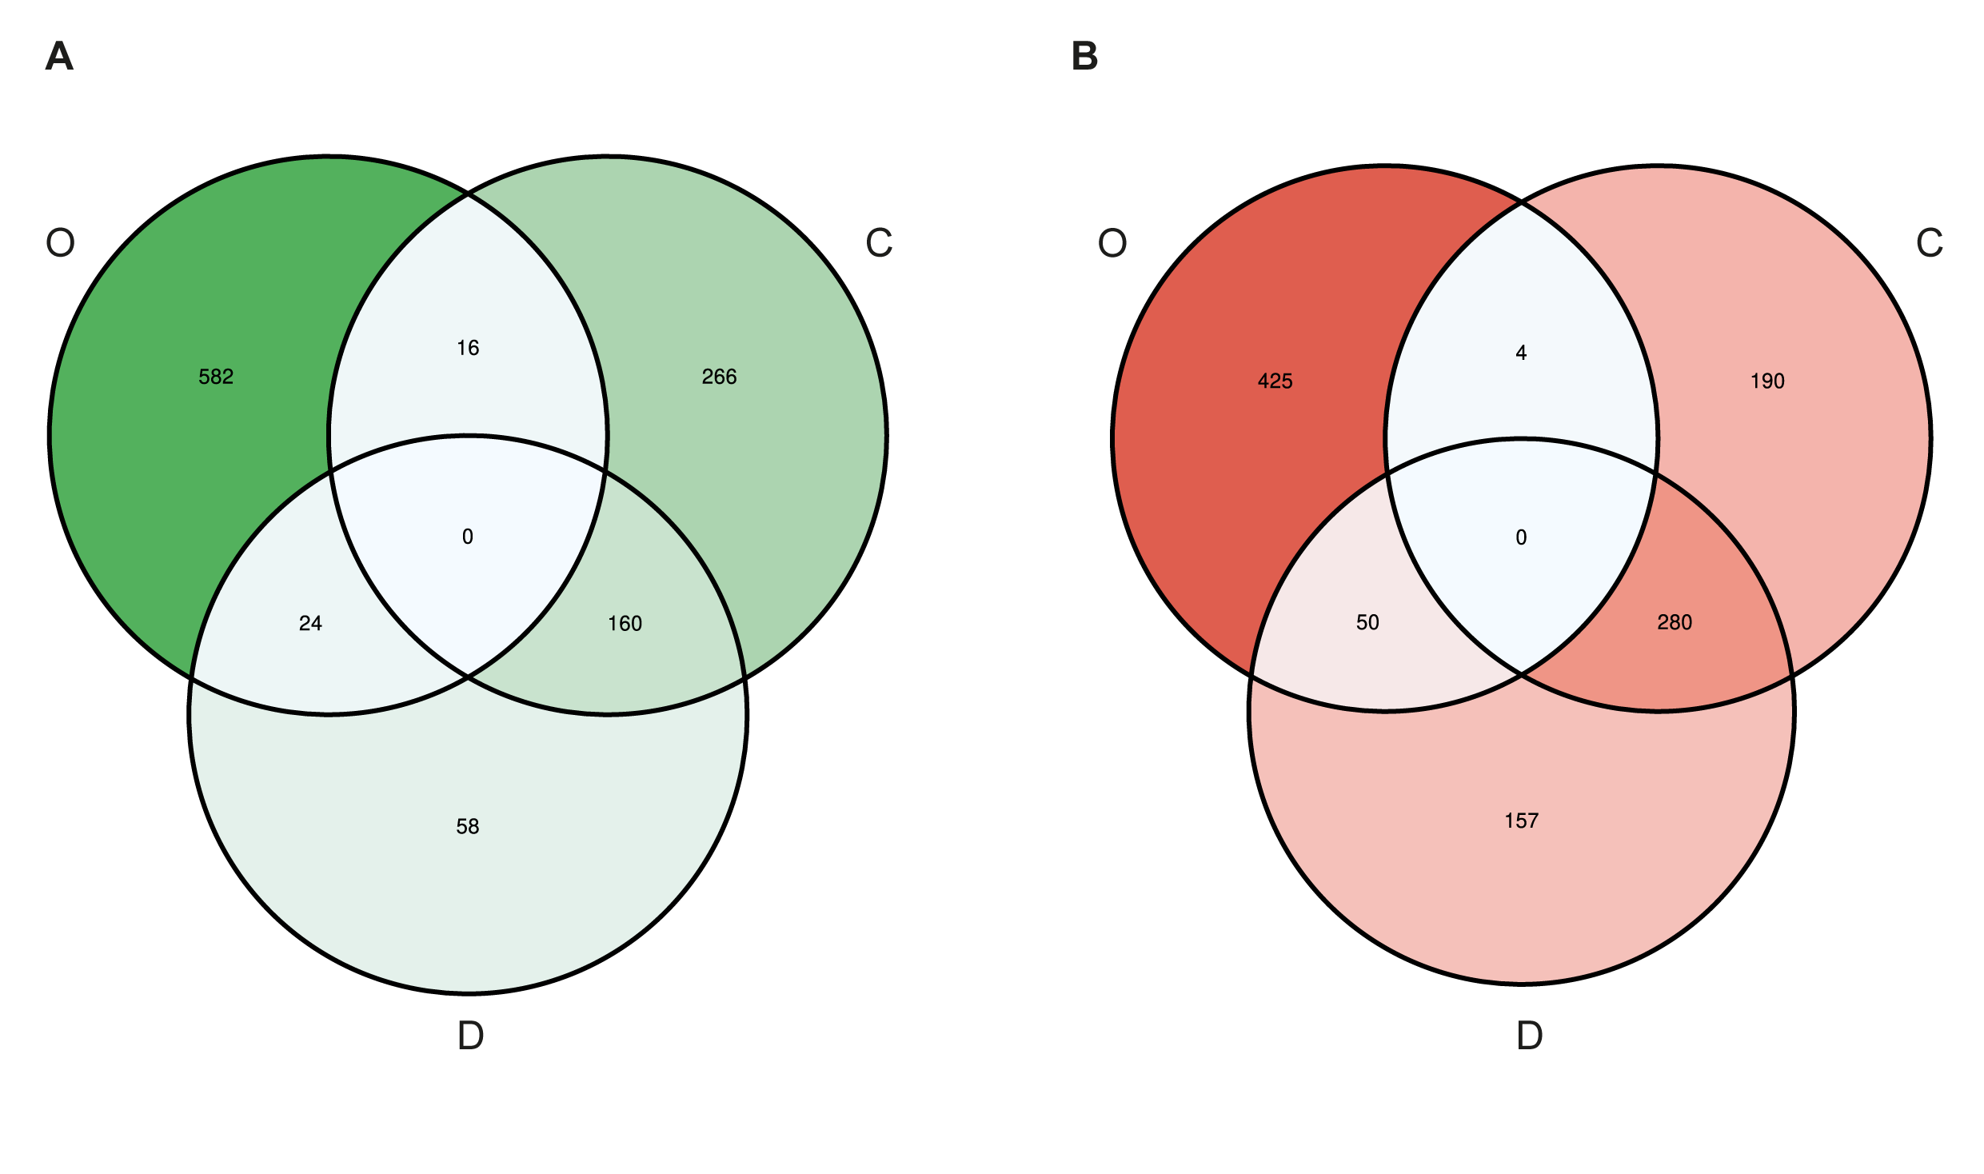
Fig. S2. Venn’s diagrams of 1106 differentially expressed transcripts (DETs) (Wald’s test, p-value_{adj} < 0.01, Log2FoldChange > 1) across Leucosolenia corallorrhiza body regions. A — the upregulated DETs. B — the downregulated DETs. C — cormus tubes, D — diverticula, O — oscular rims.

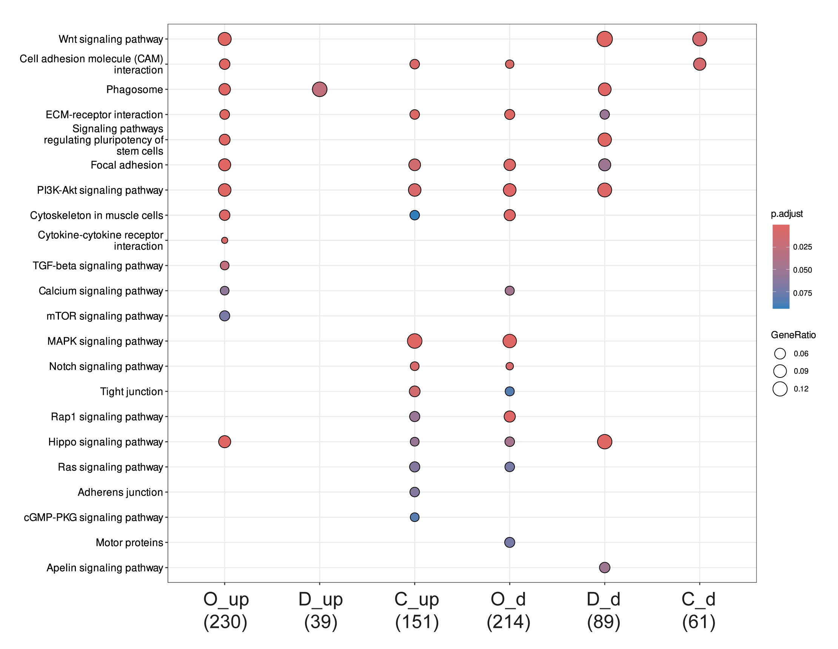
Fig. S3. Kyoto Encyclopedia of Genes and Genomes (KEGG) enrichments of up- and downregulated non-unique differentially expressed transcripts (DETs) (Wald’s test, p-value_{adj} < 0.01, Log2FoldChange > 1) of Leucosolenia corallorrhiza body regions. C — cormus tubes, D — diverticula, O — oscular rims, _up — upregulated DETs, _d — downregulated DETs.
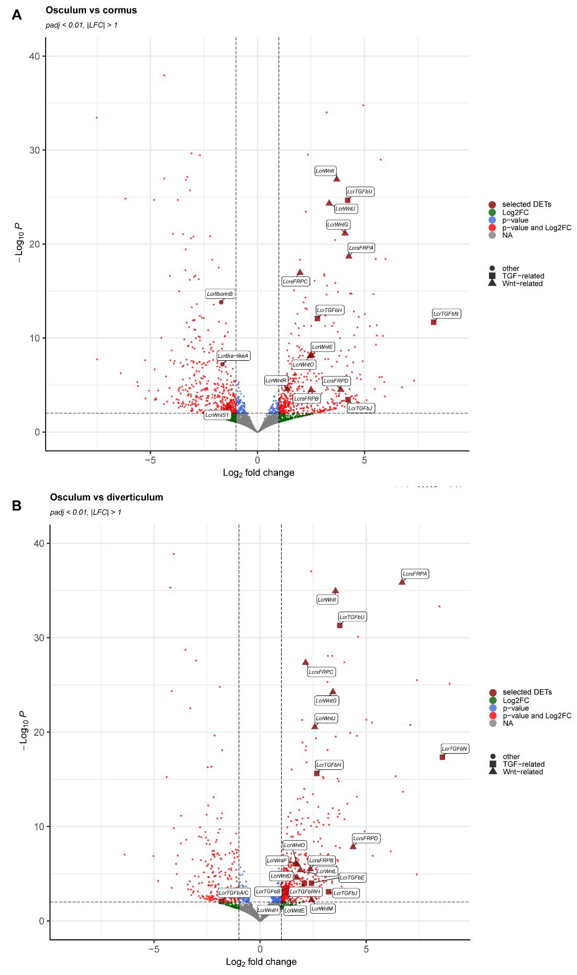
Fig. S4. Volcano plot of differentially expressed transcripts (DETs) (Wald’s test, p-value_{adj} < 0.01, |Log2FoldChange| > 1). A — DETs between the oscular rim and cormus tubes samples. B — DETs between the oscular rim and diverticula samples. Labels mark manually selected DETs.

